Samsung Price Intelligence — Data Analysis
📌 Project Overview
This project presents a complete end-to-end data analysis of Samsung smartphones, built using a custom GSMArena web scraping pipeline and exploratory data analysis in Python.
The objective is to understand:
- 📈 The evolution of Samsung smartphone hardware over time
- 🔍 Hardware specification trends (RAM, Battery, Display, Storage)
- 📊 Differences across Galaxy series (S, A, M, Z, F)
- 🧠 Strategic product positioning through data
This notebook demonstrates data acquisition, cleaning, analysis, visualization, and business interpretation — reflecting a real-world data science workflow.

🏢 About Samsung
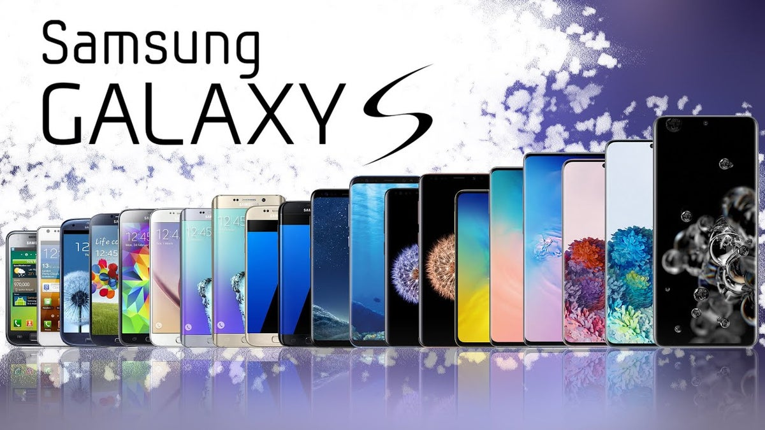
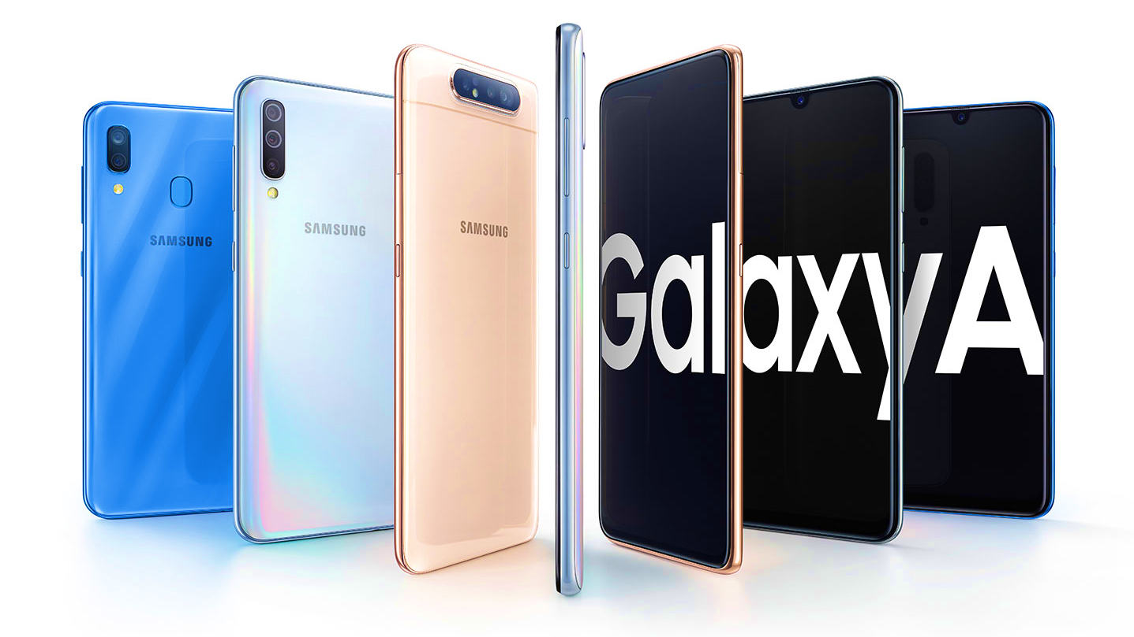
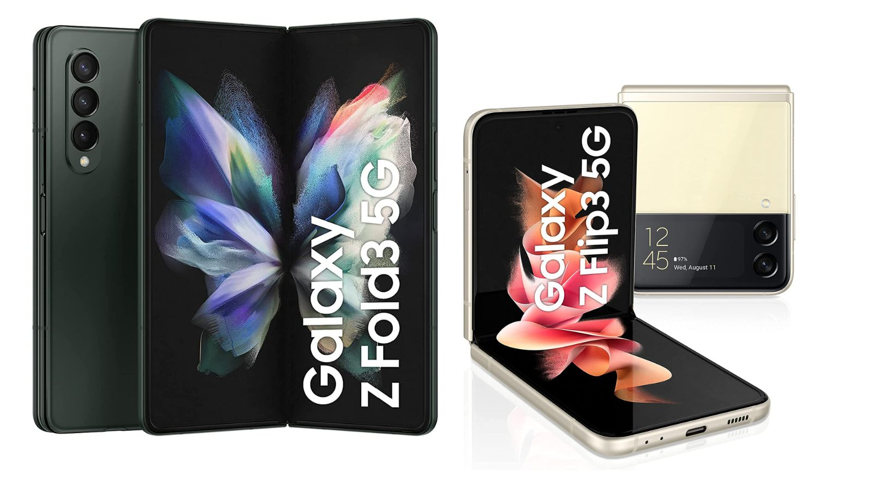
Samsung Electronics is one of the world's leading smartphone manufacturers, known for its diverse Galaxy lineup:
- Galaxy S → Flagship innovation
- Galaxy A / M / F → Mid-range & mass-market
- Galaxy Z → Premium foldable devices
This project analyzes how these series evolved technically and strategically.

📂 Dataset Information
📊 Data Source
- Custom-built GSMArena scraping pipeline
- Output file: samsung_features.csv
- Contains structured smartphone specifications
🧾 Key Features
- Model Name
- Release Year
- RAM (GB)
- Storage (GB)
- Battery Capacity (mAh)
- Display Size (inches)
- Performance Score (engineered feature)
- Series (S, A, M, Z, F)
- Device Age
This demonstrates full ownership of the data pipeline — from scraping to structured analysis.

🧠 Notebook Structure
1️⃣ Title & Project Context
- Project objective explanation
- Business context of Samsung Galaxy lineup
- Data source transparency

2️⃣ Import Libraries & Load Data
Libraries used:
pandas
matplotlib
seaborn
datetime
Steps performed:
- Load samsung_features.csv
- Inspect dataset shape
- Review column names
- Display first few rows
Purpose:
- Confirm data readiness
- Validate schema integrity

3️⃣ Data Overview & Quality Check
Analysis includes:
- Missing value summary
- Data types verification
- Statistical summary (describe())
Key Observations:
- Most devices cluster around 6–8 GB RAM
- Battery capacity stabilizes near 5000 mAh
- Display sizes trend upward over time
Recruiter Insight:
Interpretation is added alongside analysis — not just raw output.

4️⃣ Trend Analysis Over Time
📈 RAM Evolution
- Average RAM per release year
- Clear upward trend from low-memory devices to high-capacity smartphones
- Acceleration in flagship generations
🔋 Battery Capacity Trend
- Average battery capacity by year
- Stabilization around 5000 mAh
- Innovation constraints due to safety and device thickness
📱 Display Size Trend
- Gradual increase in screen size
- Shift toward content consumption and media-focused devices
Business Interpretation:
- Hardware growth aligns with user demand for performance and multimedia usage.

5️⃣ Galaxy Series Comparison
Series Compared:
- S
- A
- M
- Z
- F
Visualizations:
- Average RAM per series
- Average Battery per series
- Performance Score comparison
Strategic Insights:
- S Series → Premium flagship innovation
- A / M / F Series → High-volume mid-range market
- Z Series → Experimental foldable premium niche
This section connects data analysis to product strategy.

6️⃣ Correlation Heatmap
Analyzed numeric relationships among:
- RAM
- Storage
- Battery
- Display Size
- Performance Score
- Device Age
Insights:
- Strong positive relationship between RAM and performance
- Storage moderately correlates with performance tier
- Battery size has limited correlation with performance
- Device age negatively impacts perceived performance tier
Interview Relevance:
Correlation analysis is a common technical discussion topic.

7️⃣ Release Cycle Insights
Exploration includes:
- Number of Samsung devices launched per year
- Series-wise distribution over time
Key Findings:
- Increasing release frequency in mid-range categories
- Expansion of Galaxy A and M series portfolio
- Emergence and gradual growth of foldable (Z series)
- Flagship launches remain controlled and premium-positioned
Business Angle:
Samsung balances:
- Innovation leadership
- Mass-market coverage
- Category experimentation

8️⃣ Key Findings Summary
- 📈 RAM capacity steadily increased across all segments.
- 🔋 Battery capacity stabilized near 5000 mAh after 2020.
- 📱 Display sizes increased as smartphones became media devices.
- 📊 Mid-range series dominate total launches.
- 🔬 Foldable devices remain premium and limited.
- 🧠 Performance perception is heavily influenced by RAM and storage.
This section summarizes actionable insights — not code.

9️⃣ Future Work
Planned improvements:
- 💰 Add price data for price-performance analysis
- 🤖 Build ML model to predict price or performance tier
- 📊 Compare Samsung trends with other brands
- 📈 Time-series forecasting for hardware evolution
Demonstrates forward-thinking data strategy.

